EAGLE EXAMINATION BOARD
PRE-MOCK EXAMINATION 2023 SET II


PRIMARY SEVEN
INTEGRATED SCIENCE
Time allowed: 2 hours 30 minutes
School EMIS  Index No. |  |  |  |  |  | Personal NO.
CANDIDATE’S NAME……………………………………………………………………………….…..…
CANDIDATES’ SIGNATURE: …………………………………………………………………………
READ THE FOLLOWING INSTRUCTIONS CAREFULLY:
- This paper has two sections: A and B.
- Section A has 40 short questions (40 marks).
- Section B has 15 questions (60 marks).
- Attempt All questions. All answers to both Sections A and B must be written in the spaces provided.
- All answers must be written using blue or black ball-point pen or ink. Only diagrams should be drawn using pencils in the spaces provided.
- Unnecessary alteration of work may lead to loss of marks.
- Any handwriting that cannot be easily read will lead to loss of marks.
- Do not fill anything in the boxes indicated

FOR OFFICIAL USE ONLY
SECTION | EXAMS MARKS | T/L MARKS | OFFICE
A
B
TOTAL
SECTION A (40 MARKS)
1. What is the main natural source of heat?
_______________________________________________________
2. When should one brush her / his teeth?
_______________________________________________________
3. State one device that uses electro magnets to work.
_______________________________________________________
4. How does a puff ball reproduce?
_______________________________________________________
5. Why should a person include a solvent in preparing oral rehydration salts?
_______________________________________________________
6. Why is carbon dioxide used in fire extinguishers?
_______________________________________________________
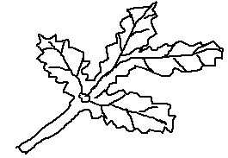
7. The diagram below show a type of a leaf.

Name the type of leaf shown above.
_______________________________________________________
8. How is debeaking useful in poultry farming?
_______________________________________________________
9. Give one example of non-renewable resource in the environment.
_______________________________________________________
10. How are eggs of birds able to carry out gaseous exchange?
_______________________________________________________
_______________________________________________________
11. Identify one cereal crop in the environment.
_______________________________________________________

12. In the space below, draw a diagram to show convex lens.

13. To which group of invertebrates does a water snail belong?
_______________________________________________________
14. Give any one way white blood cells fight disease germs.
_______________________________________________________
15. The diagram below shows a simple machine. Show the direction of movement of the wheels using arrows.


16. Which part of the human tooth protects it from injury?
_______________________________________________________
17. State the function of the melanin found in the malphigian layer.
______________________________________________________________________________________________________________
18. In which way are butterflies friendly to farmers?
_______________________________________________________
19. Mention one disease which is controlled by encouraging people to wash hands after visiting a latrine.
_______________________________________________________
20. What is the function of blood in the body?
______________________________________________________________________________________________________________
21. Name the force which makes passengers in a bus to fall forward when the driver suddenly applies the brakes.
_______________________________________________________
22. By what process does heat move from point A to B?
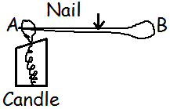
_______________________________________
_______________________________________
23. Mention the habitat for marine animals.
_______________________________________________________
24. Give one advantage of zero grazing method of keeping cattle.
______________________________________________________________________________________________________________
25. What causes sleeping sickness in man?
_______________________________________________________
26. How do conifer plants reproduce?
_______________________________________________________
27. Mention any one reason for planting trees together with crops in the garden. _________________________________________________
_______________________________________________________
28. State the law of levers (moments)
______________________________________________________________________________________________________________
29. Identify one activity carried out in the community that leads to deforestation.
_______________________________________________________
30. State the method used to maintain moisture in the vegetable garden.
______________________________________________________________________________________________________________
31. Give one importance of earthworms in the soil.
______________________________________________________________________________________________________________
32. Which organ in the body stores bile?
_______________________________________________________
33. Give one quality of laboratory manufacture drugs.
______________________________________________________________________________________________________________
34. State one characteristic of seeds of dispersed by wind.
______________________________________________________________________________________________________________
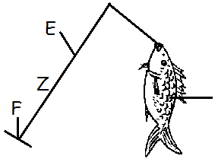
35. To which class of levers does the diagram below belong?

________________________________________
________________________________________
36. State any one danger of weeds in a garden.
_______________________________________________________
37. A man uses a torch which has 3 dry cells. What is the voltage of the torch?

_______________________________________________________
38. What does an ovule develop into after fertilization?
_______________________________________________________
39. What name is given to the hair got from goats?
_______________________________________________________
40. Of what importance is breast feeding to a mother?
_______________________________________________________
SECTION B
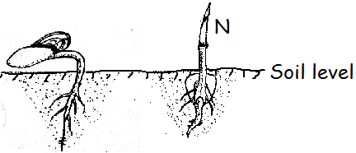
41. The diagram below shows two seeds germinating. Use it to answer questions that follow.

(a) Name the type of germination shown in the diagrams M and N.
(i) M: ___________________________________________________
(ii) N: __________________________________________________
(b) Which type of leaf venation does seedling marked M have?
_______________________________________________________
(c) Name the type of root system possessed by seedling marked N.
_______________________________________________________
42. The arrangement of organisms below shows a food chain.
Grass Locust Lizard Eagle
(a) Use arrows to show the flow of energy among the organism.
(b) Which organism is regarded as;
(i) Producer? _____________________________________________
(ii) Tertiary consumer?
_______________________________________________________
(c) How are bacteria important in the food chain?
______________________________________________________________________________________________________________
43. (a) What do you understand by the term silting?
______________________________________________________________________________________________________________
(b) Identify one effect of silting.
_______________________________________________________
(c) Name one cause of silting.
_______________________________________________________
(d) Describe one way of conserving the environment.
_______________________________________________________
44. (a) Write any two activities which can be done by the family to promote family hygiene.
i) ______________________________________________________
ii) _____________________________________________________
(b) State two ways how the community can be sensitized about health issues.
i) ______________________________________________________
ii) _____________________________________________________
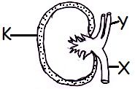
45. The diagram below is of the excretory organ. Use it to answer the questions that follow:

(a) Name the parts marked with letters.
Y: _____________________________________________________
(b) State the function of part marked K.
______________________________________________________________________________________________________________
(c) Besides kidneys, name any other example of excretory organ.
_______________________________________________________
46. (a) How are bees important in the economy of a country like Uganda?
______________________________________________________________________________________________________________

(b) Why is it a bad practice to set an apiary in the school compound?
______________________________________________________________________________________________________________

(c) Give two causes of swarming in bees.
i) ______________________________________________________
ii) _____________________________________________________
47. (a) Complete the table below:
Disease | Vaccine | site of immunization
 | BCG | Upper right arm
Polio | Polio vaccine
Whooping cough |  | Left upper thigh

(b) Why is DPT vaccine referred to as triple vaccine?
______________________________________________________________________________________________________________
48. (a) State the difference between pitch of sound and volume of sound.
______________________________________________________________________________________________________________
(b) Write any two factors which determine the pitch of sound.
i) ______________________________________________________
ii) _____________________________________________________
(c) Give one way of storing sound.
_______________________________________________________
49. Use the diagram below to answer the following questions.

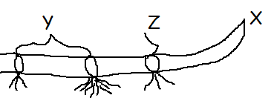

(a) Name the parts labeled Y and X.
(i) Y: ___________________________________________________
(ii) X: __________________________________________________
(b) What is the importance of part marked Z in propagation?
______________________________________________________________________________________________________________
(c) Name the type of roots marked P.
_______________________________________________________
50. The diagram below shows the dispersion of light. Use it to answer the questions which follow:
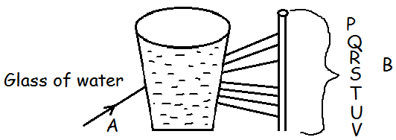

(a) Name the parts marked A and B.
(i) A: ___________________________________________________
(ii) B: ___________________________________________________
(b) Name the colour marked R.
_______________________________________________________
(c) Why does a blue shirt appear blue?
_______________________________________________________
(d) Write one example of an essential drug.
_______________________________________________________
51. (a) What is drug misuse?
______________________________________________________________________________________________________________
(b) State one way how people misuse drugs.
_______________________________________________________
(c) Why is it dangerous to buy drugs from any shop?
______________________________________________________________________________________________________________
(d) Give one example of an essential drug.
_______________________________________________________
52. (a) Why is dustbin important in a home?
_______________________________________________________
(b) Give two uses of windows on a house.
i) ______________________________________________________
ii) _____________________________________________________
(c) Why are ventilators put at a higher level than windows on a house?
_______________________________________________________
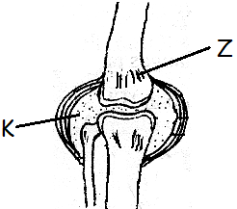
53. The diagram below shows a human body joint. Use it to answer the following questions.

(a) Name the type of movable joint shown below.
_______________________________________________________
(b) Name the part labeled Z.
_______________________________________________________
(c) How useful is the fluid marked K in the joint?
______________________________________________________________________________________________________________
(d) Which part of the skeleton protects the Spinal cord?
_______________________________________________________
54. Match the words in list A with those in list B.
A B
Kwashiorkor lack of Vitamin D
Marasmus lack of calcium
Rickets lack of iron
Anaemia lack of carbohydrates
lack of proteins

(i) Kwashiorkor: _______________________________________
(ii) Marasmus: _______________________________________
(iii) Rickets: _______________________________________
(iv) Anaemia: _______________________________________

55. (a) Why are snakes classified under vertebrates?
_______________________________________________________
(b) Give any one example of poisonous snake.
_______________________________________________________
(c) State one health practice that can help one to avoid snake bites.
______________________________________________________________________________________________________________
(d) Give the first aid for snake bite.
______________________________________________________________________________________________________________

*****GOD BLESS*****

